EE4266 Assignment 2

Part 1: Determining the fundamental matrix

1. Picking points

Initially corner detection method was applied to find the points of interest. However, the effect did not meet the expectation:

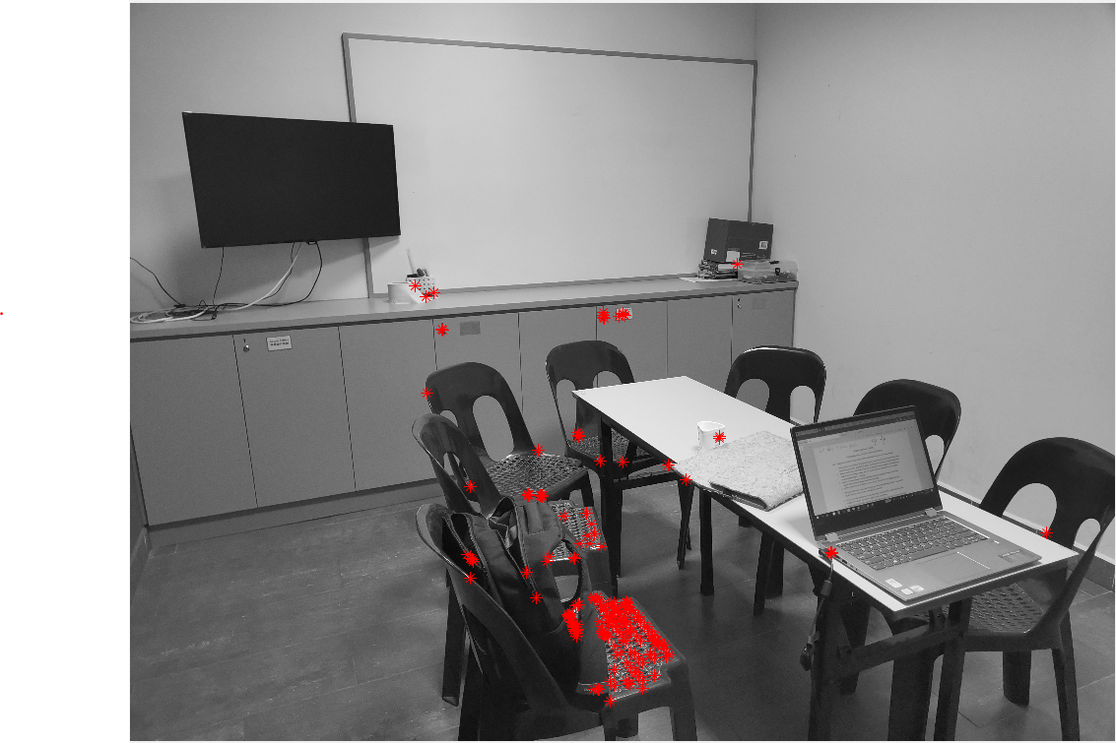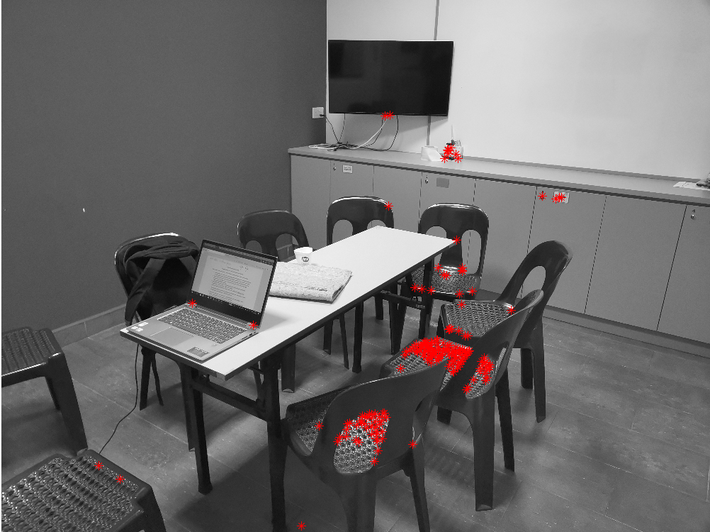

It can be seen that the points picked hardly represent some form of corners and there is no one-to-one correspondence. Therefore, the corner detection approach was abandoned due to its low robustness. Instead, 8 pairs of corresponding points were manually selected from two images respectively:

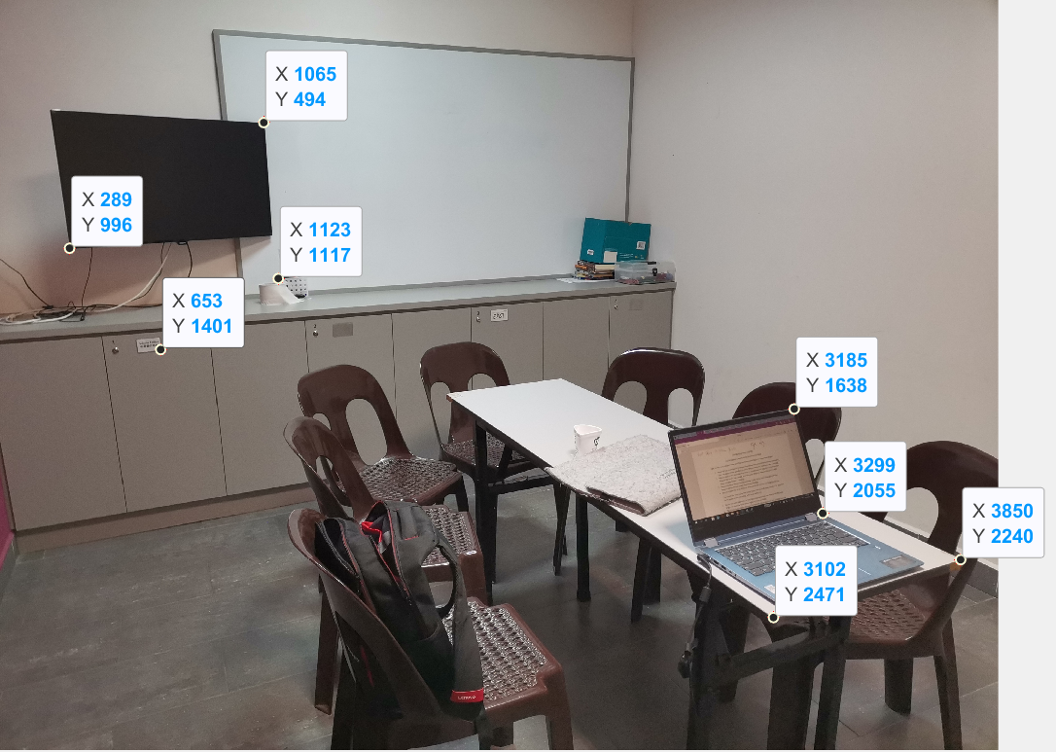

The coordinates of the corresponding points from the left image L are: (3185, 1638), (3299, 2055), (3850, 2240), (289, 996), (3102, 2471), (1065, 494), (653, 1401), (1123, 1117).

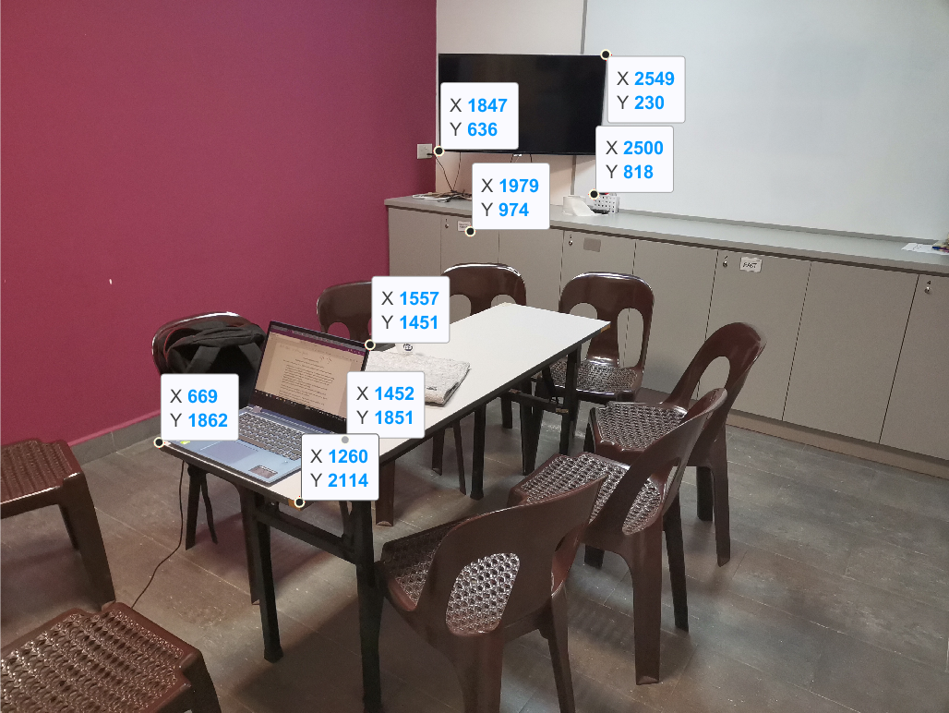

The coordinates of the points from the right image R are: (1557, 1451), (1452, 1851), (1260, 2114), (1847, 636), (669, 1862), (2549, 230), (1979, 974), (2500, 818).

We use the technique provided in the notes to compute the fundamental matrix:

1. Arrange the points’ coordinates and the elements of fundamental matrix into a linear system of equations:

$$\left(\begin{matrix}u_{1}{u_{1}}^{'} & u_{1}{v_{1}}^{'} & u_{1} & v_{1}{u_{1}}^{'} & v_{1}{v_{1}}^{'} & v_{1} & {u_{1}}^{'} & {v_{1}}^{'} \\ u_{2}{u_{2}}^{'} & u_{2}{v_{2}}^{'} & u_{2} & v_{2}{u_{2}}^{'} & v_{2}{v_{2}}^{'} & v_{2} & {u_{2}}^{'} & {v_{2}}^{'} \\ u_{3}{u_{3}}^{'} & u_{3}{v_{3}}^{'} & u_{3} & v_{3}{u_{3}}^{'} & v_{3}{v_{3}}^{'} & v_{3} & {u_{3}}^{'} & {v_{3}}^{'} \\ u_{4}{u_{4}}^{'} & u_{4}{v_{4}}^{'} & u_{4} & v_{4}{u_{4}}^{'} & v_{4}{v_{4}}^{'} & v_{4} & {u_{4}}^{'} & {v_{4}}^{'} \\ u_{5}{u_{5}}^{'} & u_{5}{v_{5}}^{'} & u_{5} & v_{5}{u_{5}}^{'} & v_{5}{v_{5}}^{'} & v_{5} & {u_{5}}^{'} & {v_{5}}^{'} \\ u_{6}{u_{6}}^{'} & u_{6}{v_{6}}^{'} & u_{6} & v_{6}{u_{6}}^{'} & v_{6}{v_{6}}^{'} & v_{6} & {u_{6}}^{'} & {v_{6}}^{'} \\ u_{7}{u_{7}}^{'} & u_{7}{v_{7}}^{'} & u_{7} & v_{7}{u_{7}}^{'} & v_{7}{v_{7}}^{'} & v_{7} & {u_{7}}^{'} & {v_{7}}^{'} \\ u_{8}{u_{8}}^{'} & u_{8}{v_{8}}^{'} & u_{8} & v_{8}{u_{8}}^{'} & v_{8}{v_{8}}^{'} & v_{8} & {u_{8}}^{'} & {v_{8}}^{'}\end{matrix}\right)\left(\begin{matrix}F_{11} \\ F_{12} \\ F_{13} \\ F_{21} \\ F_{22} \\ F_{23} \\ F_{31} \\ F_{32}\end{matrix}\right)=-\left(\begin{matrix}1 \\ 1 \\ 1 \\ 1 \\ 1 \\ 1 \\ 1 \\ 1\end{matrix}\right)$$

Where $\left(u_{i},v_{j}\right)$ and $\left({u_{i}}^{'},{v_{j}}^{'}\right)$ denote the coordinates of the points from the left and right image L and R respectively.

Substitute in the values found from image L and R:

$$\left(\begin{matrix}(3185)(1557) & (1557)(1638) & 1557 & (1451)(3185) & (1451)(1638) & 1451 & 3185 & 1638 \\ (3299)(1452) & (1452)(2055) & 1452 & (1851)(3299) & (1851)(2055) & 1851 & 3299 & 2055 \\ (3850)(1260) & (1260)(2240) & 1260 & (2114)(3850) & (2114)(2240) & 2114 & 3850 & 2240 \\ (289)(1847) & (1847)(996) & 1847 & (636)(289) & (636)(996) & 636 & 289 & 996 \\ (3102)(669) & (669)(2471) & 669 & (1862)(3102) & (1862)(2471) & 1862 & 3102 & 2471 \\ (1065)(2549) & (2549)(494) & 2549 & (230)(1065) & (230)(494) & 230 & 1065 & 494 \\ (653)(1979) & (1979)(1401) & 1979 & (974)(653) & (974)(1401) & 974 & 653 & 1401 \\ (1123)(2500) & (2500)(1117) & 2500 & (818)(1123) & (818)(1117) & 818 & 1123 & 1117\end{matrix}\right)\left(\begin{matrix}F_{11} \\ F_{12} \\ F_{13} \\ F_{21} \\ F_{22} \\ F_{23} \\ F_{31} \\ F_{32}\end{matrix}\right)=-\left(\begin{matrix}1 \\ 1 \\ 1 \\ 1 \\ 1 \\ 1 \\ 1 \\ 1\end{matrix}\right)$$

Use the augmented matrix representation:

$$\left(\begin{matrix}(1557)(3185) & (1557)(1638) & 1557 & (1451)(3185) & (1451)(1638) & 1451 & 3185 & 1638 \\ (1452)(3299) & (1452)(2055) & 1452 & (1851)(3299) & (1851)(2055) & 1851 & 3299 & 2055 \\ (1260)(3850) & (1260)(2240) & 1260 & (2114)(3850) & (2114)(2240) & 2114 & 3850 & 2240 \\ (1847)(289) & (1847)(996) & 1847 & (636)(289) & (636)(996) & 636 & 289 & 996 \\ (669)(3102) & (669)(2471) & 669 & (1862)(3102) & (1862)(2471) & 1862 & 3102 & 2471 \\ (2549)(1065) & (2549)(494) & 2549 & (230)(1065) & (230)(494) & 230 & 1065 & 494 \\ (1979)(653) & (1979)(1401) & 1979 & (974)(653) & (974)(1401) & 974 & 653 & 1401 \\ (2500)(1123) & (2500)(1117) & 2500 & (818)(1123) & (818)(1117) & 818 & 1123 & 1117\end{matrix} | \begin{matrix}-1 \\ -1 \\ -1 \\ -1 \\ -1 \\ -1 \\ -1 \\ -1\end{matrix}\right)$$

Use Gaussian elimination to obtain its reduced row echelon form by using the MATLAB command ‘rref()’:

$$\left(\begin{matrix}1 & 0 & 0 & 0 & 0 & 0 & 0 & 0 \\ 0 & 1 & 0 & 0 & 0 & 0 & 0 & 0 \\ 0 & 0 & 1 & 0 & 0 & 0 & 0 & 0 \\ 0 & 0 & 0 & 1 & 0 & 0 & 0 & 0 \\ 0 & 0 & 0 & 0 & 1 & 0 & 0 & 0 \\ 0 & 0 & 0 & 0 & 0 & 1 & 0 & 0 \\ 0 & 0 & 0 & 0 & 0 & 0 & 1 & 0 \\ 0 & 0 & 0 & 0 & 0 & 0 & 0 & 1\end{matrix} | \begin{matrix}0 \\ 0 \\ -0.001574803149606 \\ 0 \\ 0 \\ -0.013986013986014 \\ -0.001457725947522 \\ 0.008064516129032\end{matrix}\right)$$

Therefore we have:

$F_{11}=0$, $F_{12}=0$, $F_{13}=-0.001574803149606$, $F_{21}=0$, $F_{22}=0$, $F_{23}=-0.013986013986014$, $F_{31}=-0.001457725947522$, $F_{32}=0.008064516129032$.

Therefore, the fundamental matrix

$F=\left(\begin{matrix}0 & 0 & -0.001574803149606 \\ 0 & 0 & -0.013986013986014 \\ -0.001457725947522 & 0.008064516129032 & 1\end{matrix}\right)$

We check that $F$ is rank-2 which satisfies the rank deficiency constraint.

Proof check:

Let $x_{i}=\left(\begin{matrix}u_{i} & v_{i} & 1\end{matrix}\right)$, ${x'}_{i}=\left(\begin{matrix}{u'}_{i} & {v'}_{i} & 1\end{matrix}\right)$ to be the homogeneous coordinates of image A and B respectively.

$x_{i}F{{x'}_{i}}^{T}=\left(\begin{matrix}-13.1788545211460 \\ -13.8363801674481 \\ -18.0984143038652 \\ -3.19279104674517 \\ -10.6899478834197 \\ -3.79956361149804 \\ -5.39242100240594 \\ -7.00652903751292\end{matrix}\right)$ for integer $i$ ranges from 1 to 8

This result has observable discrepancy since we expect $x_{i}F{{x'}_{i}}^{T}=0$. This might arise of the floating point error during the matrix manipulation and computation. Therefore, it is necessary to use an alternative technique.

MATLAB System of Linear Equations solver:

X = linsolve(A,B)

Produced the following results:

$F_{11}=4.98845848000000e-07$, $F_{12}=1.65720528300000e-06$, $F_{13}=-0.00157397941783700$, $F_{21}=1.76977692500000e-06$, $F_{22}=-7.25449046000000e-07$, $F_{23}=-0.0139788539625590$, $F_{31}-0.00145691093589900$, $F_{32}=0.00807037768992400$.

The fundamental matrix is now

$F'=\left(\begin{matrix}4.98845848000000e-07 & 1.65720528300000e-06 & -0.00157397941783700 \\ 1.76977692500000e-06 & -7.25449046000000e-07 & -0.0139788539625590 \\ -0.00145691093589900 & 0.00807037768992400 & 1\end{matrix}\right)$

However, after checking $F'$ is rank-3. Therefore, we need to manually impose the rank deficient constraint.

Apply singular value decomposition to $F'$ by using MATLAB command [U,S,V] = svd(F):

$$F^{'}=USV^{T} (where U and V are orthogonal matrices and S is diagonal)=\left(\begin{matrix}-0.001573705267380 & -0.126238839372377 & 0.991998628469639 \\ -0.013976539886993 & -0.991900184796639 & -0.126248484082704 \\ 0.999901085000170 & -0.014063386303048 & -0.000203423628246\end{matrix}\right)$$

$$\left(\begin{matrix}1.000132554337549 & 0 & 0 \\ 0 & 0.000114522566732 & 0 \\ 0 & 0 & 0.000000575492986\end{matrix}\right)$$

$${\left(\begin{matrix}-0.001456599267397 & 0.163030624039341 & 0.986619933887369 \\ 0.008068517422849 & -0.986586948914469 & 0.163037085530370 \\ 0.999966388107706 & 0.008198039825642 & 0.000121646396493\end{matrix}\right)}^{T}$$

Set the smallest singular value of $F^{'}$ to be 0 and obtain the new matrix $F^{'}$:

$$F^{'}'=\left(\begin{matrix}-0.001573705267380 & -0.126238839372377 & 0.991998628469639 \\ -0.013976539886993 & -0.991900184796639 & -0.126248484082704 \\ 0.999901085000170 & -0.014063386303048 & -0.000203423628246\end{matrix}\right)$$

$$\left(\begin{matrix}1.000132554337549 & 0 & 0 \\ 0 & 0.000114522566732 & 0 \\ 0 & 0 & 0\end{matrix}\right)$$

$${\left(\begin{matrix}-0.001456599267397 & 0.163030624039341 & 0.986619933887369 \\ 0.008068517422849 & -0.986586948914469 & 0.163037085530370 \\ 0.999966388107706 & 0.008198039825642 & 0.000121646396493\end{matrix}\right)}^{T}$$

$$=\left(\begin{matrix}-0.000000064403882 & 0.000001564129326 & -0.001573979487283 \\ 0.000001841459912 & -0.000000713603567 & -0.013978853953721 \\ -0.001456910820397 & 0.008070377709011 & 1.000000000000014\end{matrix}\right)$$

Proof check:

$x_{i}F''{{x'}_{i}}^{T}=\left(\begin{matrix}-2.67112634917550 \\ -3.92082633624158 \\ -2.35550833780380 \\ -0.451197639845997 \\ -0.854204084929073 \\ -1.62734281042060 \\ -0.924184786863956 \\ -1.76456596441808\end{matrix}\right)$ for integer $i$ ranges from 1 to 8

It is obvious that the result has less discrepancies as compared to the first method.

Therefore, we adapt the second result $F''$.

Part 2: Determining the epipolar line